Terraform Challenge

Write a code using Terraform that deploys and achieves the following:-
- Create an EC2 Instance on AWS Cloud using the below-mentioned ubuntu AMI and instance_type. Or, (You can use of your choice as well) ami = "ami-0461b1436c9b3c1a3" instance_type = "t2.micro"
- Install a web server on the same EC2 Instance. The web server should listen on port 8080.
- Create a Docker-compose file for the project:https://github.com/betawins/cricbuzz-docker-hello-world.gitand point it to port 8000.
- Make the web server point to the above service so that 8080 returns the response from the Docker service.
- Configure to Save the Logs in the location /var/log/cb.log
- Write the Log rotate configuration for the above file

Provision an AWS EC2 instance using Terraform and automatically deploy a Hello World application using Docker Compose. Configure Nginx as a reverse proxy and expose the application through port 8080.
Lets get started with the main.tf file
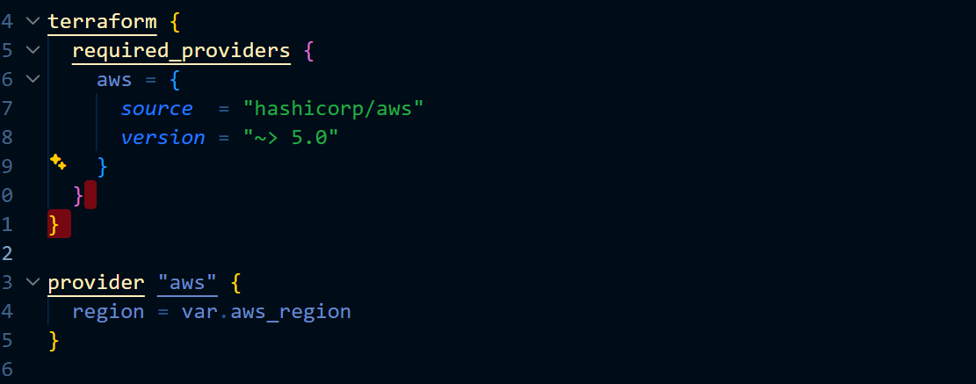
Purpose
- Uses AWS Provider version 5.0
- Deploys resources in the configured AWS region

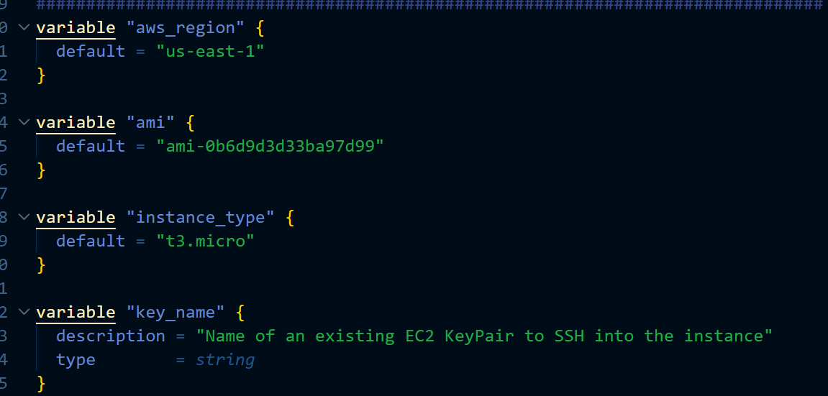
Variables
Defined reusable variables:
Purpose
Allows customization without modifying the main code.

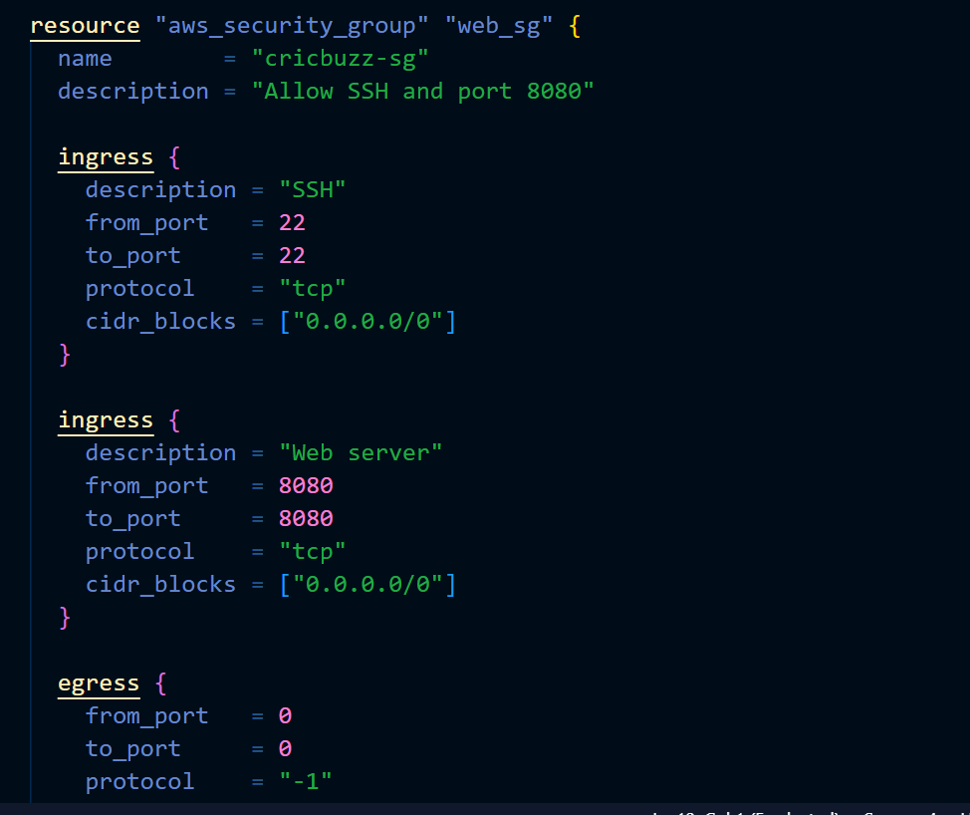
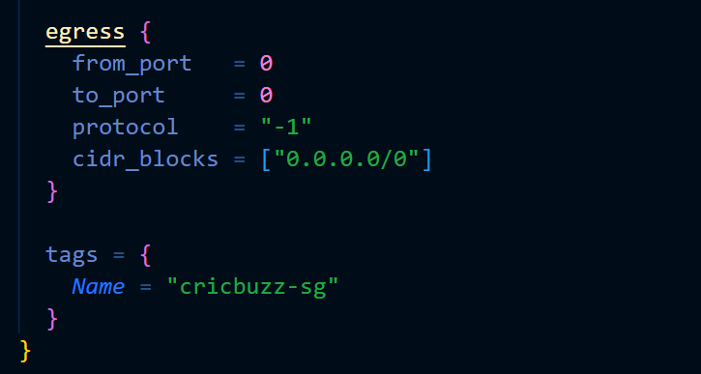
Creation of security group and allowing ports 8080,22

Purpose
- SSH into server
- Access application through browser

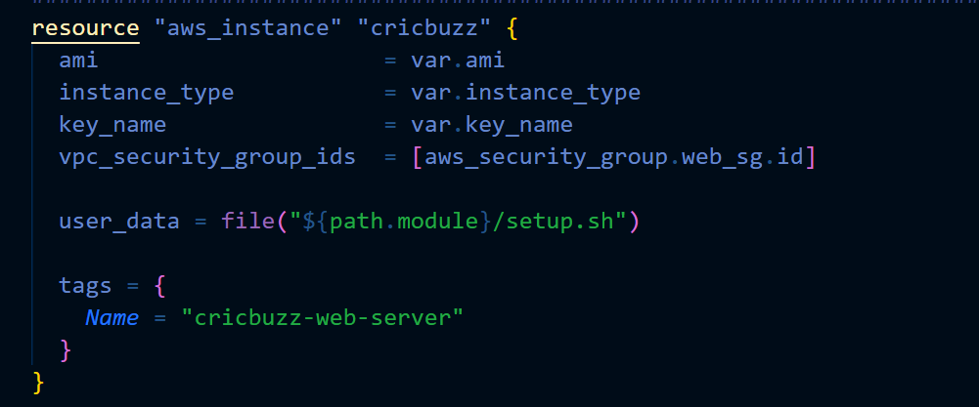
Ec2 instance creation using the values from the variable block also using setup.sh file for userdata (bootstrapping)
Purpose
- Launch EC2 automatically
- Execute setup.sh during boot

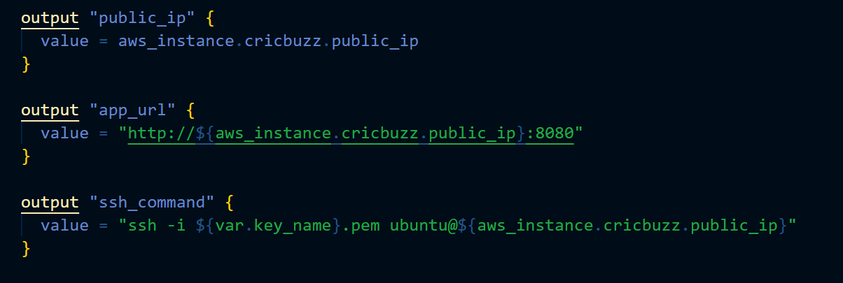
Outputs
Created useful outputs.
Purpose
Displays:
Public IP
Application URL
SSH Command
after Terraform deployment.

setup.sh Automation Script
The entire application deployment is automated through User Data
Step 1: Update Server
Purpose:
- Updates package repository.

Step 2: Install Required Packages

Step 2: Install Required Packages

installed:
- Git
- Nginx
- Curl
- Security packages

Step 3: Install Docker
Added Docker official repository.
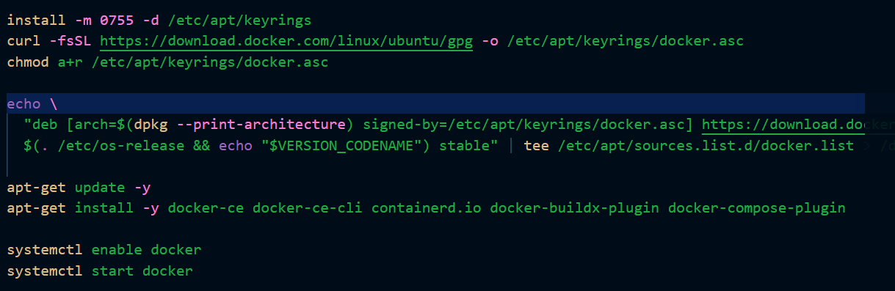
Installed:
docker-ce
docker-ce-cli
containerd.io
docker-compose-plugin
Enabled Docker:

Step 4: Clone Application Repository
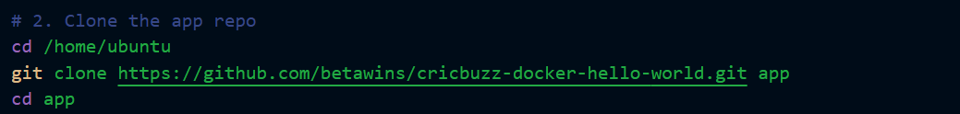
Repository cloned into:
/home/ubuntu/app

Step 5: Build Docker Image
Created a custom Dockerfile.

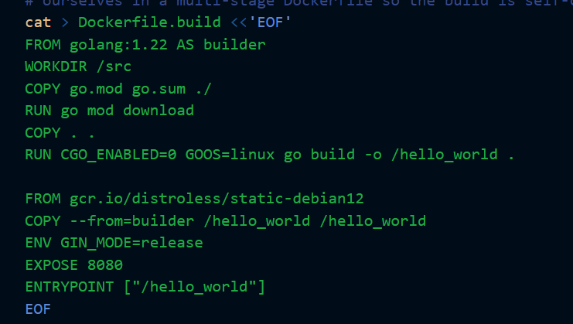
Why Multi-Stage?
Benefits:
- Smaller image size
- Better security
- Faster deployment

Step 6: Docker Compose Deployment
Created docker-compose.yml
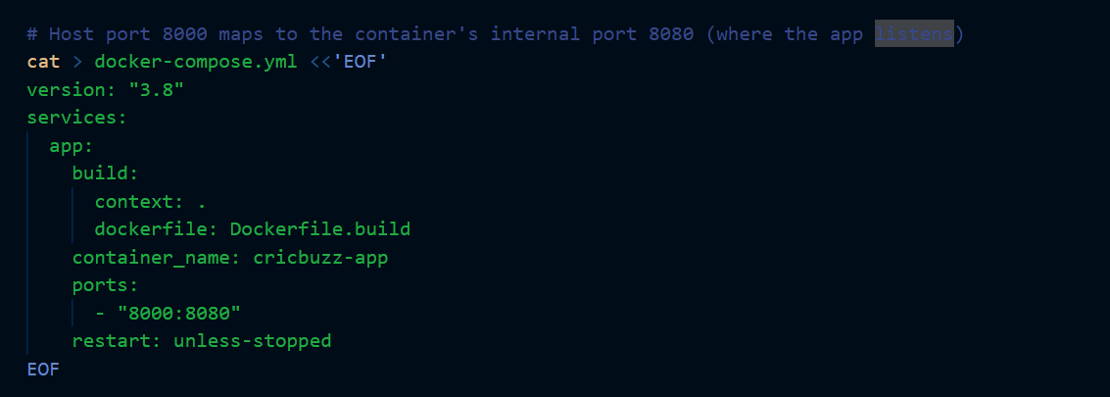Port Mapping
Host | Container
8000 | 8080
Application listens internally on:
8080
Host exposes:
8000
Step 7: Start Application
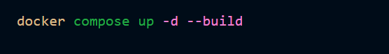
Purpose:
- Builds image
- Creates container
- Runs application in background

Step 8: Configure Nginx Reverse Proxy
Created Nginx Virtual Host:

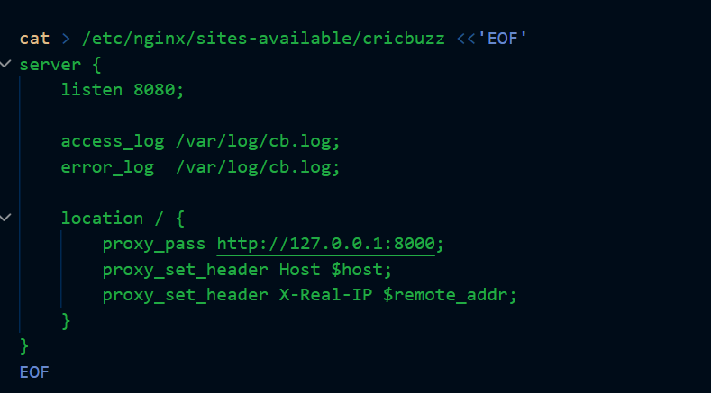
Purpose
User accesses:
http://Public-IP:8080
Nginx forwards request to:
http://127.0.0.1:8000
which reaches Docker container.

Step 9: Restart Nginx
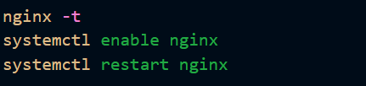

Step 10: Logging Configuration
Created log file:
/var/log/cb.log
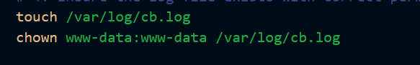
Used by Nginx for:
- Access Logs
- Error Logs

Step 11: Log Rotation

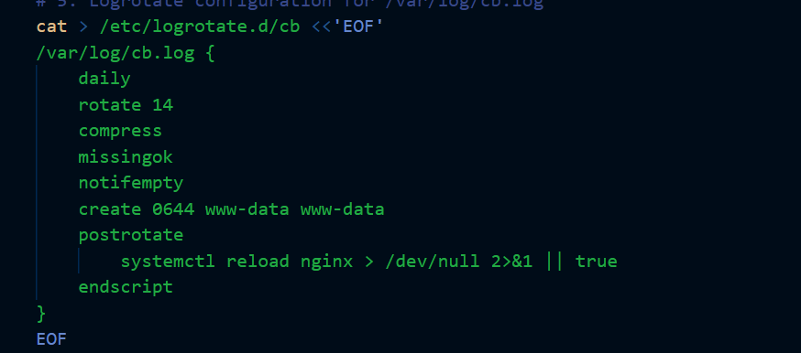
Configured
/etc/logrotate.d/cb
Settings:
- Daily rotation
- 14 backups retained
- Compression enabled
Benefits:
- Prevents disk space issues
- Maintains application logs
- Lets apply the changes now
Initialize Terraform
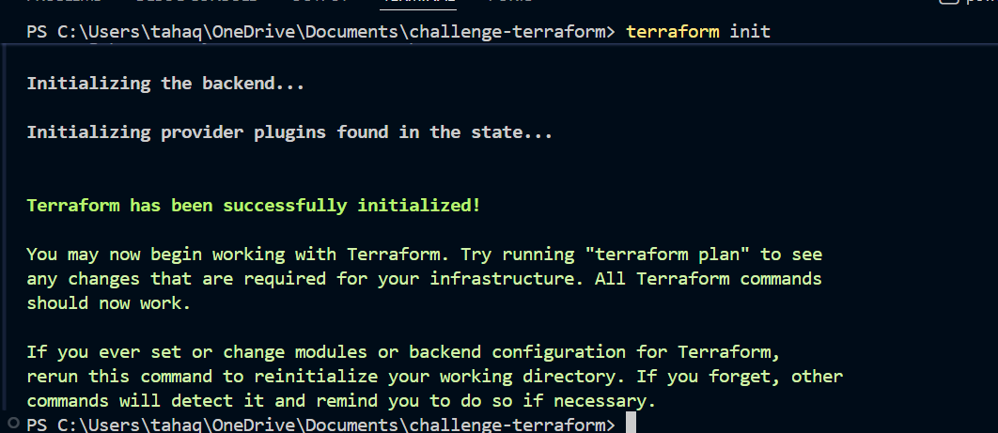
Validate
Preview Changes
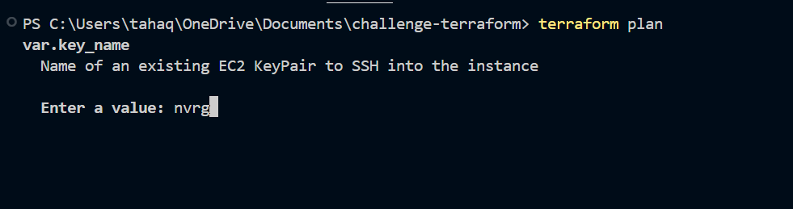
It asks for the keypair enter the existing keypair
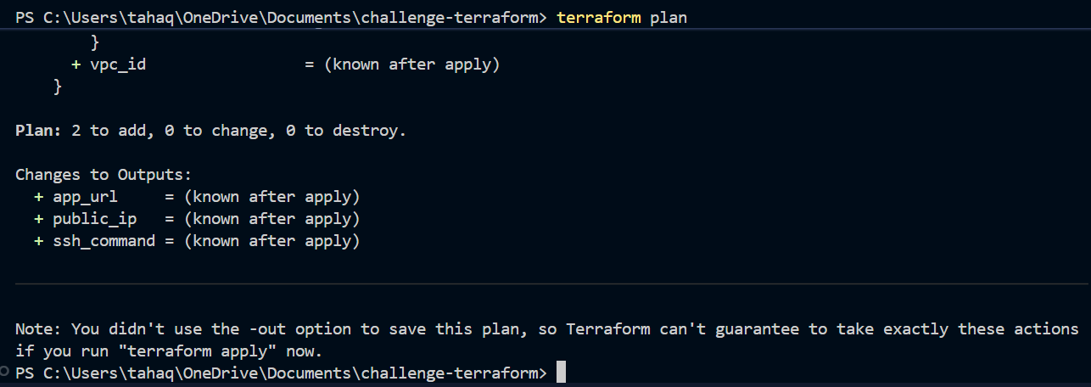
Deploy
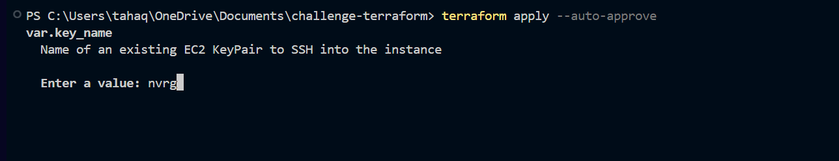
Again asks for the keypair name provide it and proceed
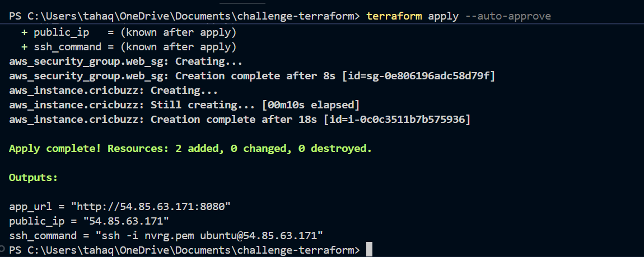
The changes are applied and the instance with all the requirements has been created
In the output it shows the application url
Public ip of the instance
And ssh command using which we can remotely connect to the instance
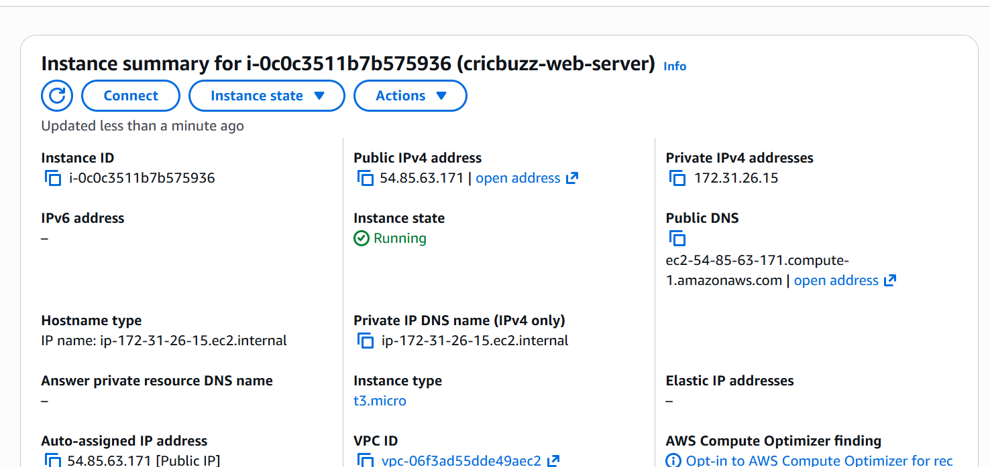
The instance is been created
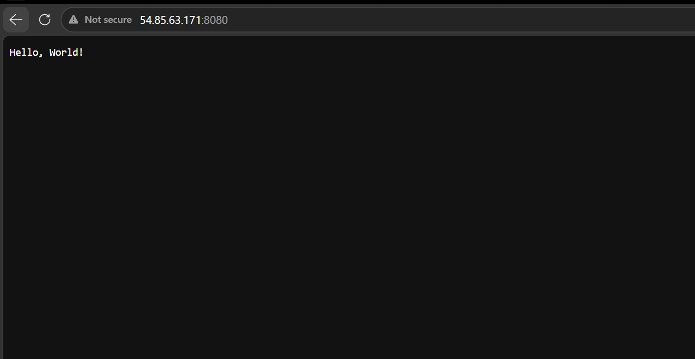
The application is also accessible through url
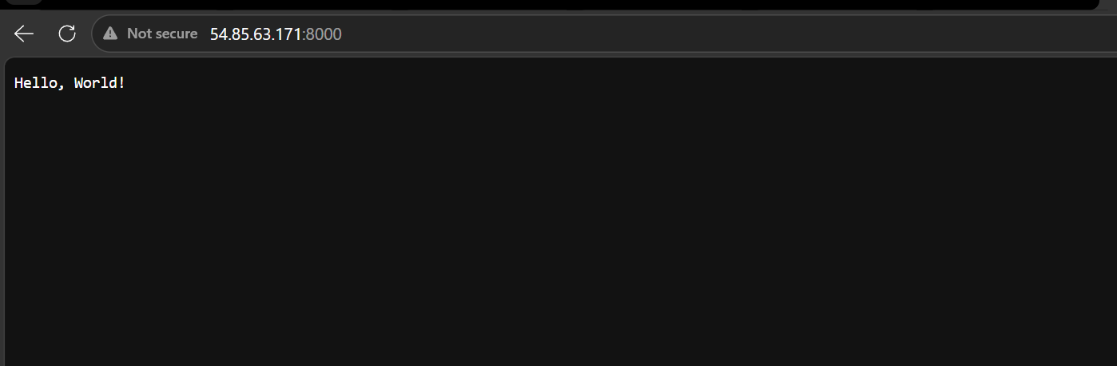
This confirms our setup is working fine if we access the nginx reverse proxy it is redirecting to the application

Lets login to instance now and check the logs are configured or not
Ssh to instance
Switch to root
And go inside the log directory
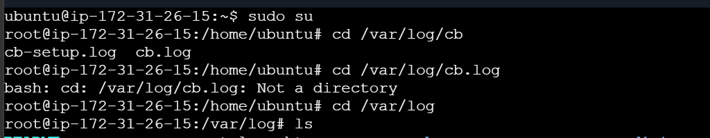
use cat command to read the logs ensure that logs are written
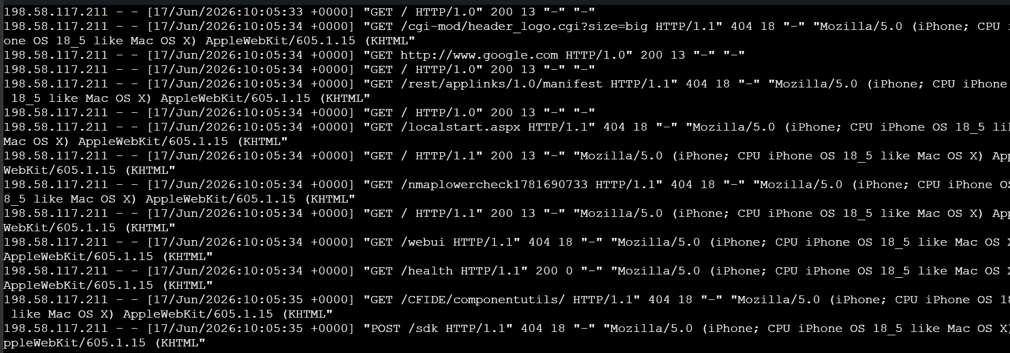
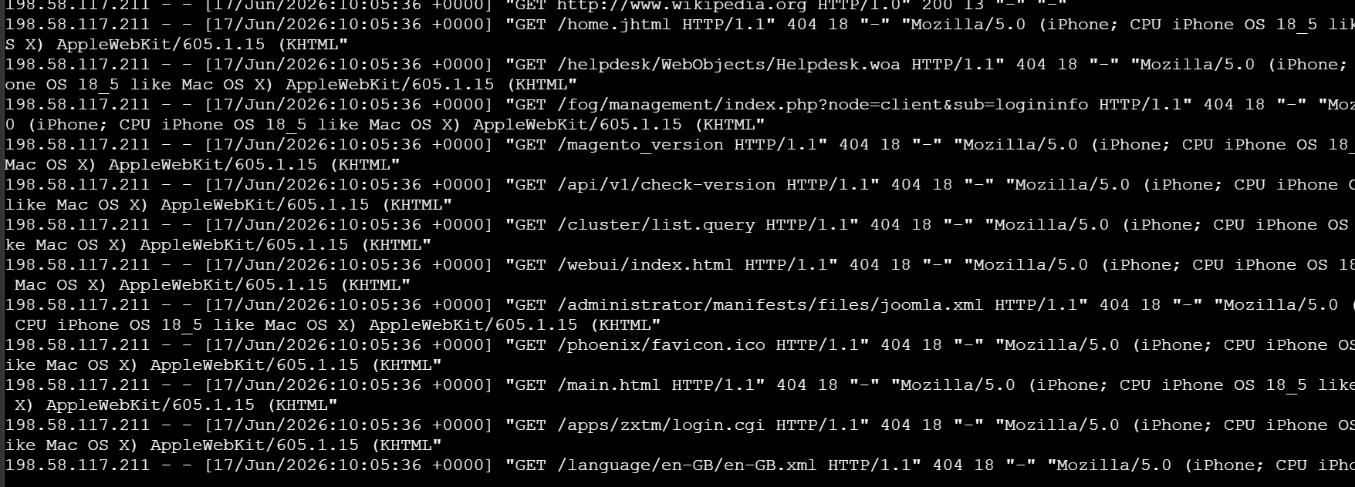
Verify the log configuration if it includes all the things which we configured in setup.sh
Go to the location
/etc/logrotate.b/
And read the file using cat command
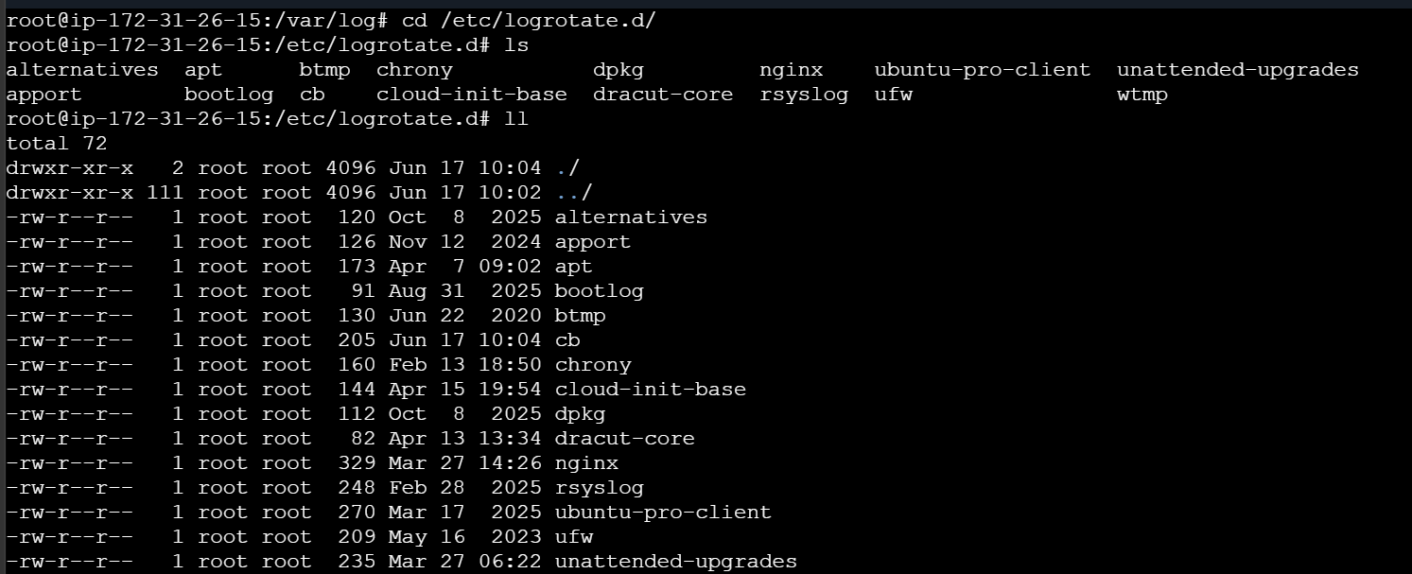
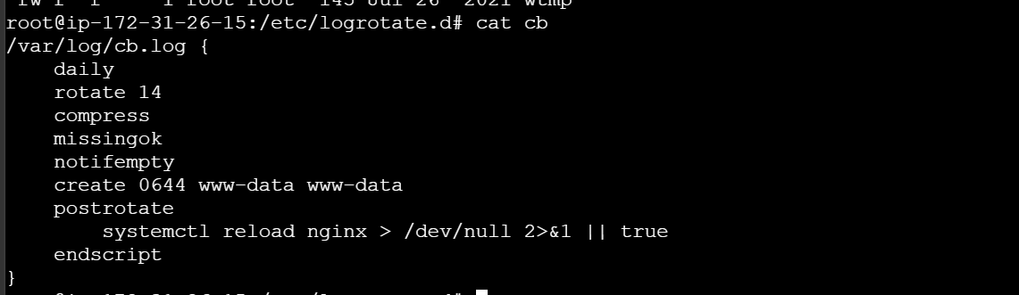
This confirms the logs are configured properly

Main.tf script:
###############################################################################
# Terraform + AWS Provider
###############################################################################
terraform {
required_providers {
aws = {
source = "hashicorp/aws"
version = "~> 5.0"
}
}
}

provider "aws" {
region = var.aws_region
}

###############################################################################
# Variables
###############################################################################
variable "aws_region" {
default = "us-east-1"
}

variable "ami" {
default = "ami-0b6d9d3d33ba97d99"
}

variable "instance_type" {
default = "t3.micro"
}

variable "key_name" {
description = "Name of an existing EC2 KeyPair to SSH into the instance"
type = string
}

###############################################################################
# Security Group: SSH (22), Web server (8080)
###############################################################################
resource "aws_security_group" "web_sg" {
name = "cricbuzz-sg"
description = "Allow SSH and port 8080"

ingress {
description = "SSH"
from_port = 22
to_port = 22
protocol = "tcp"
cidr_blocks = ["0.0.0.0/0"]
}

ingress {
description = "Web server"
from_port = 8080
to_port = 8080
protocol = "tcp"
cidr_blocks = ["0.0.0.0/0"]
}

egress {
from_port = 0
to_port = 0
protocol = "-1"
cidr_blocks = ["0.0.0.0/0"]
}

tags = {
Name = "cricbuzz-sg"
}
}

###############################################################################
# EC2 Instance
###############################################################################
resource "aws_instance" "cricbuzz" {
ami = var.ami
instance_type = var.instance_type
key_name = var.key_name
vpc_security_group_ids = [aws_security_group.web_sg.id]

user_data = file("${path.module}/setup.sh")

tags = {
Name = "cricbuzz-web-server"
}
}

###############################################################################
# Outputs
###############################################################################
output "public_ip" {
value = aws_instance.cricbuzz.public_ip
}

output "app_url" {
value = "http://${aws_instance.cricbuzz.public_ip}:8080"
}

output "ssh_command" {
value = "ssh -i ${var.key_name}.pem ubuntu@${aws_instance.cricbuzz.public_ip}"
}

Setup.sh
#!/bin/bash
set -e
exec > /var/log/cb-setup.log 2>&1
echo "=== setup.sh started: $(date) ==="

# 1. Install Docker (engine + compose plugin) from Docker's official repo,
# plus Nginx and Git. The Ubuntu-packaged 'docker-compose' is unreliable
# across AMIs, so we use Docker's own apt repo for a consistent install.
apt-get update -y
apt-get install -y ca-certificates curl gnupg git nginx

install -m 0755 -d /etc/apt/keyrings
curl -fsSL https://download.docker.com/linux/ubuntu/gpg -o /etc/apt/keyrings/docker.asc
chmod a+r /etc/apt/keyrings/docker.asc

echo \
"deb [arch=$(dpkg --print-architecture) signed-by=/etc/apt/keyrings/docker.asc] https://download.docker.com/linux/ubuntu \
$(. /etc/os-release && echo "$VERSION_CODENAME") stable" | tee /etc/apt/sources.list.d/docker.list > /dev/null

apt-get update -y
apt-get install -y docker-ce docker-ce-cli containerd.io docker-buildx-plugin docker-compose-plugin

systemctl enable docker
systemctl start docker

# 2. Clone the app repo
cd /home/ubuntu
git clone https://github.com/betawins/cricbuzz-docker-hello-world.git app
cd app

# The repo's own Dockerfile expects a pre-built 'hello_world' binary to already
# exist (it just COPYs it into a scratch image) and the app listens on 8080
# internally. Rather than rely on the repo's Makefile, we build the Go binary
# ourselves in a multi-stage Dockerfile so the build is self-contained.
cat > Dockerfile.build <<'EOF'
FROM golang:1.22 AS builder
WORKDIR /src
COPY go.mod go.sum ./
RUN go mod download
COPY . .
RUN CGO_ENABLED=0 GOOS=linux go build -o /hello_world .

FROM gcr.io/distroless/static-debian12
COPY --from=builder /hello_world /hello_world
ENV GIN_MODE=release
EXPOSE 8080
ENTRYPOINT ["/hello_world"]
EOF

# Host port 8000 maps to the container's internal port 8080 (where the app listens)
cat > docker-compose.yml <<'EOF'
version: "3.8"
services:
app:
build:
context: .
dockerfile: Dockerfile.build
container_name: cricbuzz-app
ports:
- "8000:8080"
restart: unless-stopped
EOF

docker compose up -d --build

# 3. Configure Nginx as the web server on port 8080, proxying to port 8000
rm -f /etc/nginx/sites-enabled/default

cat > /etc/nginx/sites-available/cricbuzz <<'EOF'
server {
listen 8080;

access_log /var/log/cb.log;
error_log /var/log/cb.log;

location / {
proxy_pass http://127.0.0.1:8000;
proxy_set_header Host $host;
proxy_set_header X-Real-IP $remote_addr;
}
}
EOF

ln -sf /etc/nginx/sites-available/cricbuzz /etc/nginx/sites-enabled/cricbuzz

nginx -t
systemctl enable nginx
systemctl restart nginx

# 4. Ensure the log file exists with correct permissions
touch /var/log/cb.log
chown www-data:www-data /var/log/cb.log

# 5. Logrotate configuration for /var/log/cb.log
cat > /etc/logrotate.d/cb <<'EOF'
/var/log/cb.log {
daily
rotate 14
compress
missingok
notifempty
create 0644 www-data www-data
postrotate
systemctl reload nginx > /dev/null 2>&1 || true
endscript
}
EOF

echo "=== setup.sh finished: $(date) ==="

